UML basics: The component diagram
This is the next installment in a series of articles about the essential diagrams used within the Unified Modeling Language, or UML. In my previous article on the UML's class diagram, (The Rational Edge, September 2004), I described how the class diagram's notation set is the basis for all UML 2's structure diagrams. Continuing down the track of UML 2 structure diagrams, this article introduces the component diagram.
The diagram's purpose
The component diagram's main purpose is to show the structural relationships between the components of a system. In UML 1.1, a component represented implementation items, such as files and executables. Unfortunately, this conflicted with the more common use of the term component," which refers to things such as COM components. Over time and across successive releases of UML, the original UML meaning of components was mostly lost. UML 2 officially changes the essential meaning of the component concept; in UML 2, components are considered autonomous, encapsulated units within a system or subsystem that provide one or more interfaces. Although the UML 2 specification does not strictly state it, components are larger design units that represent things that will typically be implemented using replaceable" modules. But, unlike UML 1.x, components are now strictly logical, design-time constructs. The idea is that you can easily reuse and/or substitute a different component implementation in your designs because a component encapsulates behavior and implements specified interfaces. [Note: The physical items that UML1.x called components are now called "artifacts" in UML 2. An artifact is a physical unit, such as a file, executable, script, database, etc. Only artifacts live on physical nodes; classes and components do not have "location." However, an artifact may manifest components and other classifiers (i.e., classes). A single component could be manifested by multiple artifacts, which could be on the same or different nodes, so a single component could indirectly be implemented on multiple nodes.]

Resources we think you'll like
- Free 90 day trial of IBM UML tools
- IBM software architecture e-kit
- IBM Rational Software Architect wiki
- IBM Academic Initiative
- Drive your UML modeling process with the new IBM Rational Software Architect Version 8.0 solution
In component-based development (CBD), component diagrams offer architects a natural format to begin modeling a solution. Component diagrams allow an architect to verify that a system's required functionality is being implemented by components, thus ensuring that the eventual system will be acceptable.
In addition, component diagrams are useful communication tools for various groups. The diagrams can be presented to key project stakeholders and implementation staff. While component diagrams are generally geared towards a system's implementation staff, component diagrams can generally put stakeholders at ease because the diagram presents an early understanding of the overall system that is being built.
Developers find the component diagram useful because it provides them with a high-level, architectural view of the system that they will be building, which helps developers begin formalizing a roadmap for the implementation, and make decisions about task assignments and/or needed skill enhancements. System administrators find component diagrams useful because they get an early view of the logical software components that will be running on their systems. Although system administrators will not be able to identify the physical machines or the physical executables from the diagram, a component diagram will nevertheless be welcomed because it provides early information about the components and their relationships (which allows sys-admins to loosely plan ahead).

Back to top
The notation
The component diagram notation set now makes it one of the easiest UML diagrams to draw. Figure 1 shows a simple component diagram using the former UML 1.4 notation; the example shows a relationship between two components: an Order System component that uses the Inventory System component. As you can see, a component in UML 1.4 was drawn as a rectangle with two smaller rectangles protruding from its left side.
Figure 1: This simple component diagram shows the Order System's general dependency using UML 1.4 notation
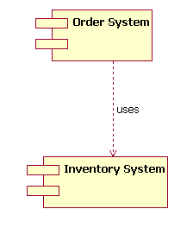
The above UML 1.4 notation is still supported in UML 2. However, the UML 1.4 notation set did not scale well in larger systems. For that reason, UML 2 dramatically enhances the notation set of the component diagram, as we will see throughout the rest of this article. The UML 2 notation set scales better, and the notation set is also more informative while maintaining its ease of understanding.
Let's step through the component diagram basics according to UML 2.

Back to top
The basics
Drawing a component in UML 2 is now very similar to drawing a class on a class diagram. In fact, in UML 2 a component is merely a specialized version of the class concept. Which means that the notation rules that apply to the class classifier also apply to the component classifier. (If you read and understood my previous article [http://www-106.ibm.com/developerworks/rational/library/content/RationalEdge/sep04/bell/index.html] regarding structure diagrams in general, and class diagrams in particular, you are well under way to understanding component diagrams.)
In UML 2, a component is drawn as a rectangle with optional compartments stacked vertically. A high-level, abstracted view of a component in UML 2 can be modeled as just a rectangle with the component's name and the component stereotype text and/or icon. The component stereotype's text is «component»" and the component stereotype icon is a rectangle with two smaller rectangles protruding on its left side (the UML 1.4 notation element for a component). Figure 2 shows three different ways a component can be drawn using the UML 2 specification.
Figure 2: The different ways to draw a component's name compartment
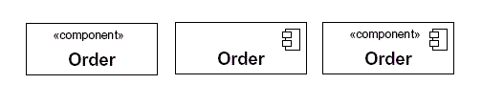
When drawing a component on a diagram, it is important that you always include the component stereotype text (the word "component" inside double angle brackets, as shown in Figure 2) and/or icon. The reason? In UML, a rectangle without any stereotype classifier is interpreted as a class element. The component stereotype and/or icon distinguishes this rectangle as a component element.
Modeling a component's interfaces Provided/Required
The Order components drawn in Figure 2 all represent valid notation elements; however, a typical component diagram includes more information. A component element can have additional compartments stacked below the name compartment. As mentioned earlier, a component is an autonomous unit that provides one or more public interfaces. The interfaces provided represent the formal contract of services the component provides to its consumers/clients. Figure 3 shows the Order component having a second compartment that denotes what interfaces the Order component provides and requires. [Note: Even though components are autonomous units they still may depend on the services provided by other components. Because of this, documenting a component's required interfaces is useful.]
Figure 3: The additional compartment here shows the interfaces that the Order component provides and requires
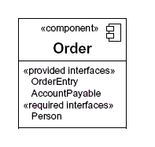
In the example Order component shown in Figure 3, the component provides the interfaces of OrderEntry and AccountPayable. Additionally, the component also requires another component that provides the Person interface. [Note: Figure 3 does not show the Order component in its complete context. In a real-world model the OrderEntry, AccountPayable, and Person interfaces would be present in the system's model.]
Another approach to modeling a component's interfaces
UML 2 has also introduced another way to show a component's provided and required interfaces. This second way builds off the single rectangle, with the component's name in it, and places what the UML 2 specification calls interface symbols" connected to the outside of the rectangle. This second approach is illustrated in Figure 4.
Figure 4: An alternative approach (compare with Figure 3) to showing a component's provided/required interfaces using interface symbols
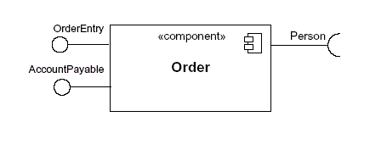
In this second approach the interface symbols with a complete circle at their end represent an interface that the component provides — this lollipop" symbol is shorthand for a realization relationship of an interface classifier. Interface symbols with only a half circle at their end (a.k.a. sockets) represent an interface that the component requires (in both cases, the interface's name is placed near the interface symbol itself). Even though Figure 4 looks much different from Figure 3, both figures provide the same information — i.e., the Order component provides two interfaces: OrderEntry and AccountPayable, and the Order component requires the Person interface.
Modeling a component's relationships
When showing a component's relationship with other components, the lollipop and socket notation must also include a dependency arrow (as used in the class diagram). On a component diagram with lollipops and sockets, note that the dependency arrow comes out of the consuming (requiring) socket and its arrow head connects with the provider's lollipop, as shown in Figure 5.
Figure 5: A component diagram that shows how the Order System component depends on other components
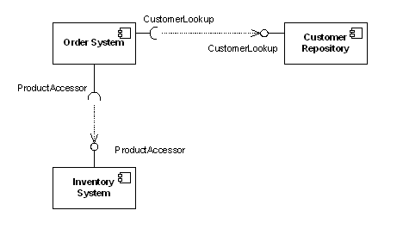
Figure 5 shows that the Order System component depends both on the Customer Repository and Inventory System components. Notice in Figure 5 the duplicated names of the interfaces CustomerLookup" and ProductAccessor." While this may seem unnecessarily repetitive in this example, the notation actually allows for different interfaces (and differing names) on each component depending on the implementation differences (e.g., one component provides an interface that is a subclass of a smaller required interface).
Subsystems
In UML 2 the subsystem classifier is a specialized version of a component classifier. Because of this, the subsystem notation element inherits all the same rules as the component notation element. The only difference is that a subsystem notation element has the keyword of subsystem" instead of component," as shown in Figure 6.
Figure 6: An example of a subsystem element
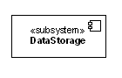
The UML 2 specification is quite vague on how a subsystem is different from a component. The specification does not treat a component or a subsystem any differently from a modeling perspective. Compared with UML 1.x, this UML 2 modeling ambiguity is new. But there's a reason. In UML 1.x, a subsystem was considered a package, and this package notation was confusing to many UML practitioners; hence UML 2 aligned subsystems as a specialized component, since this is how most UML 1.x users understood it. This change did introduce fuzziness into the picture, but this fuzziness is more of a reflection of reality versus a mistake in the UML 2 specification.
So right now you are probably scratching your head wondering when to use a component element versus a subsystem element. Quite frankly, I do not have a direct answer for you. I can tell you that the UML 2 specification says that the decision on when to use a component versus a subsystem is up to the methodology of the modeler. I personally like this answer because it helps ensure that UML stays methodology independent, which helps keep it universally usable in software development.

Back to top
Beyond the basics
The component diagram is one of the easier-to-understand diagrams, so there is not much to cover beyond the basics. However, there is one area you may consider somewhat advanced.
Showing a component's internal structure
There will be times when it makes sense to display a component's internal structure. In my previous article on the class diagram, I showed how to model a class's internal structure; here I will focus on how to model a component's internal structure when it is composed of other components.
To show a component's inner structure, you merely draw the component larger than normal and place the inner parts inside the name compartment of the encompassing component. Figure 7 show's the Store's component inner structure.
Figure 7: This component's inner structure is composed of other components
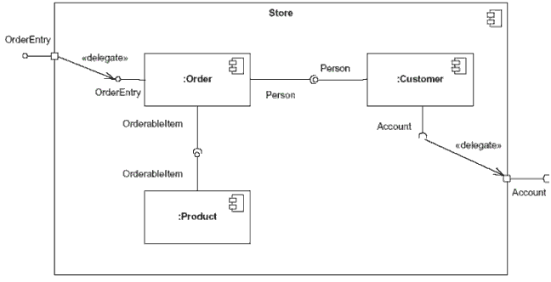
Using the example shown in Figure 7, the Store component provides the interface of OrderEntry and requires the interface of Account. The Store component is made up of three components: Order, Customer, and Product components. Notice how the Store's OrderEntry and Account interface symbols have a square on the edge of the component. This square is called a port. In a simplistic sense, ports provide a way to model how a component's provided/required interfaces relate to its internal parts. [Note: In actuality, ports are applicable to any type of classifier (i.e., to a class or some other classifier your model might have). To keep this article simple, I refer to ports in their use on component classifiers.
By using a port, our diagram is able to de-couple the internals of the Store component from external entities. In Figure 7, the OrderEntry port delegates to the Order component's OrderEntry interface for processing. Also, the internal Customer component's required Account interface is delegated to the Store component's required Account interface port. By connecting to the Account port, the internals of the Store component (e.g. the Customer component) can have a local representative of some unknown external entity which implements the port's interface. The required Account interface will be implemented by a component outside of the Store component. [Note: Typically, when you draw a dependency relationship between a port and an interface, the dependent (requiring) interface will handle all the processing logic at execution time. However, this is not a hard and fast rule — it is completely acceptable for the encompassing component (e.g., the Store component in our example) to have its own processing logic instead of merely delegating the processing to the dependant interface.]
You will also notice in Figure 7 that the interconnections between the inner components are different from those shown in Figure 5. This is because these depictions of internal structures are really collaboration diagrams nested inside the classifier (a component, in our case), since collaboration diagrams show instances or roles of classifiers. The relationship modeled between the internal components is drawn with what UML calls an assembly connector." An assembly connector ties one component's provided interface with another component's required interface. Assembly connectors are drawn as lollipop and socket symbols next to each other. Drawing these assembly connectors in this manner makes the lollipop and socket symbols very easy to read.

Back to top
Conclusion
The component diagram is a very important diagram that architects will often create early in a project. However, the component diagram's usefulness spans the life of the system. Component diagrams are invaluable because they model and document a system's architecture. Because component diagrams document a system's architecture, the developers and the eventual system administrators of the system find this work product-critical in helping them understand the system.
该文是关于在统一建模语言 2.0或UML中使用的基本图的一系列文章中的一部分。在以前关于 UML 类图中，我描述了类图的标记集如何作为所有UML 2结构图的基础。随着UML 2的轨迹，本文介绍组件图。
图的目的
组 件图的主要目的是显示系统组件间的结构关系。在 UML 1.1 中，一个组件表现了实施项目，如文件和可运行的程序。不幸地，这与组件这个术语更为普遍的用法、指象COM组件这样的东西相冲突。随着时间的推移及UML 的连续版本发布， UML 组件已经失去了最初的绝大部分含义。UML 2 正式改变了组件概念的本质意思；在 UML 2 中，组件被认为是独立的，在一个系统或子系统中的封装单位，提供一个或多个接口。虽然 UML 2 规范没有严格地声明它，但是组件是呈现事物的更大的设计单元，这些事物一般将使用可更换的组件来实现。但是，并不象在 UML 1. x中，现在，组件必须有严格的逻辑，设计时构造。主要思想是，你能容易地在你的设计中重用及/或替换一个不同的组件实现，因为一个组件封装了行为，实现了 特定接口。 ¹
在以组件为基础的开发（CBD）中，组件图为架构师提供一个开始为解决方案建模的自然形式。组件图允许一个架构师验证系统的必需功能是由组件实现的，这样确保了最终系统将会被接受。
参考 UML 基础系列的其他文章和教程
- 统一建模语言(UML) 版本 2.0
- UML基础: 统一建模语言简介
- UML 基础: 类图
- UML 基础: 序列图
- 绘制整洁的 UML 图
- 用例建模技巧
- UML 序列图简介
- 养成良好的绘制 UML 序列图的习惯
- 利用 UML 进行实体关系建模
订阅 UML 相关文章和教程的 RSS 提要

除此之外，组件图对于不同的小组是有用的交流工具。图可以呈现给关键项目发起人及实现人员。通常，当组件图将系统的实现人员连接起来的时候，组件图通常可以使项目发起人感到轻松，因为图展示了对将要被建立的整个系统的早期理解。
开 发者发现组件图是有用的，因为组件图给他们提供了将要建立的系统的高层次的架构视图，这将帮助开发者开始建立实现的路标，并决定关于任务分配及（或）增进 需求技能。系统管理员发现组件图是有用的，因为他们可以获得将运行于他们系统上的逻辑软件组件的早期视图。虽然系统管理员将无法从图上确定物理设备或物理 的可执行程序，但是，他们仍然欢迎组件图，因为它较早地提供了关于组件及其关系的信息（这允许系统管理员轻松地计划后面的工作）。

回页首

符号
在 现在，组件图符号集使它成为最容易画的 UML 图之一。图 1 显示了一个使用前 UML 1.4 符号的简单的组件图；这个例子显示两个组件之间的关系：一个使用了Inventory System组件的Order System组件。正如你所能见到的，在UML 1.4 中，用一个大方块，并且在它的左边有两个凸出的小方块，来表示组件。
图 1：这个简单的组件图使用 UML 1.4 符号显示Order System的一般性依赖关系
上 述的 UML 1.4 符号在 UML 2 中仍然被支持。然而，UML 1.4 符号集在较大的系统中不能很好地调节。关于这一点的理由是，如同我们在这篇文章的其余部分将会见到一样，UML 2 显著地增强了组件图的符号集。在维持它易于理解的条件下，UML 2 符号能够调节得更好，并且符号集也具有更多的信息。
让我们依照 UML 2 规范一步步建立组件图。

回页首

基础
现 在，在 UML 2 中画一个组件很类似于在一个类图上画一个类。事实上，在 UML 2 中，一个组件仅仅是类概念的一个特殊版本。这意味着适用于类分类器的符号规则也适用于组件分类器。（如果你已经读了并理解了我以前的关于大体上的结构图和 类图细节的文章 [http:// www. ibm.com/developerworks/cn/rational/rationaledge/content/feb05/bell /index.shtml]，你就会很易理解组件图）。
在 UML 2 中，一个组件被画成堆积着可选择小块的一个立着的长方形。UML 2 中，组件的一个高层次的抽象视图，可以用一个长方形建模，包括组件的名字和组件原型的文字和/或图标。组件原型的文本是“«component»”，而组 件原型图标是在左边有两个凸出的小长方形的一个大长方形（UML 1.4 中组件的符号元素）。图 2 显示，组件可以用UML 2规范中的三种不同方法表示。
图 2：画组件名字区的不同方法
当在图上画一个组件时，重要的是，你总要包括组件原型文本（在双重尖括号中的那个component，如图 2 所示）和/或图标。理由呢？在 UML 中，没有任何原型分类器的一个长方形被解释为一个类组件。组件原型和/或图标用来区别作为组件元素的长方形。
为组件提供/要求接口建模
在 图 2 中所画的Order组件表现了所有有效的符号元素；然而，一个典型的组件图包括更多的信息。一个组件元素可以在名字区下面附加额外的区。如前面所提到的， 一个组件是提供一个或更多公共接口的独立单元。提供的接口代表了组件提供给它的用户/客户的服务的正式契约。图 3 显示了Order组件有第二个区，用来表示Order组件提供和要求的接口。 ²
图 3：这里额外的区显示Order组件提供和要求的接口。
在图 3 中的Order组件例子中，组件提供了名为 OrderEntry 和 AccountPayable 的接口。此外，组件也要求另外一个组件提供Person接口。 ³
组件接口建模的其它方法
UML 2 也引入另外一种方法来显示组件提供并要求的接口。这个方法是建立一个里面有组件名的大长方形，并在长方形的外面放置在 UML 2 规范中称为接口符号的东西。这第二种方法在图 4 中举例说明。
图 4: 一种可选择的方法（与图3相比）：使用接口符号显示组件提供/要求的接口
在 这第二种方法中，在末端有一个完整的圆周的接口符号代表组件提供的接口 -- “棒棒糖”是这个接口分类器实现关系符号的速记法。在末端只有半个圆的接口（又称插座）符号代表组件要求的接口（在两种情况下，接口的名字被放置在接口符 号本身的附近）。即使图 4 看起来与图 3 有很大的不同，但两个图都提供了相同的信息 -- 例如，Order组件提供两个接口：OrderEntry 和 AccountPayable，而且Order组件 要求 Person接口。
组件关系的建模
当表现组件与其他的组件的关系时，棒棒糖和插座符号也必须包括一支依存箭头（如类图中所用的）。在有棒棒糖和插座的组件图上，注意，依存箭从强烈的（要求的）插座引出，并且它的箭头指向供应者的棒棒糖，如图 5 所示。
图 5：显示Order系统组件如何依赖于其他组件的组件图
图 5 显示，Order系统组件依赖于客户资源库和库存系统组件。注意在图 5 中复制出的接口名 CustomerLookup 和 ProductAccessor。 在这个例子中，这看起来可能是不必要的重复，不过符号确实允许在每个依赖于实现差别的组件中有不同的接口（和不同的名字）（举例来说，一个组件提供一个较 小的必需的接口子类）。
子系统
在 UML 2 中，子系统分类器是组件分类器的一个特别版本。因为这一点，子系统符号元素象组件符号元素一样继承所有的组件符号集规则。唯一的差别是，一个子系统符号元素由subsystem关键字代替了component，如图 6 所示。
图 6：子系统元素的一个例子
UML 2 规范在如何区别子系统与组件方面相当含糊。从建模的观点，规范并不认为组件与子系统有任何区别。与 UML 1. x 相比较，这个 UML 2 模型歧义是新的。但是有一个理由。在 UML 1. x 中，一个子系统被认为是一个软件包，而且这个软件包符号正对许多 UML 实践者造成困惑；因此，UML 2中把子系统作为特殊的组件，因为这是最多的 UML 1. x 使用者了解它的方式。这一改变确实把模糊引入图中，但是这一模糊更多的是 UML 2 规范中对抗错误的一个现实反射。
到 这里，你可能正在抓着头皮并感到疑惑，什么时候该用组件元素，什么时候又该用子系统元素。相当坦率地说，我没有一个直接的答案给你。我可以告诉你，UML 2 规范中说，何时该使用组件或子系统决定于建模者的方法论。我个人很喜欢这个答案，因为它帮助确保UML与方法论相互独立，这在软件开发中将帮助保持它的普 遍可使用。

回页首

超越基础
组件图是比较容易理解的图之一，因此没有很多超越基础的内容。然而，有一个方面你可以认为是略微困难的。
显示组件的内部结构
有时候显示组件的内部结构是有意义的。在关于类图的我的前面的文章中，我显示了该如何为类的内部结构建模；这里，当它由其他组件组成的时候，我将会关注如何为组件的内部结构建模。
为了显示组件的内部结构，你只需把组件画得比平常大一些并在名字区内放置内部的部分。图 7 显示Store组件的内部结构。
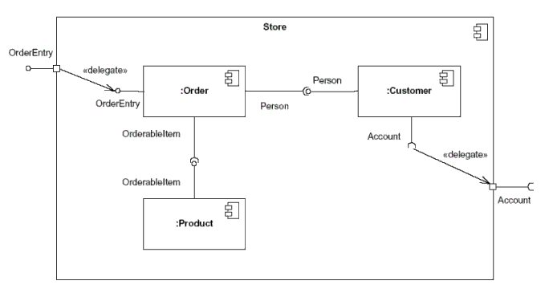
图 7: 这个组件的内部结构由其他组件组成。
使 用在图 7 中显示的例子，Store组件提供了 OrderEntry 接口并要求Account接口。Store组件由三个组件组成：Order，Customer和Product组件。注意Store的 OrderEntry 和Account接口符号在组件的边缘上为何有一个方块。这一个方块被称为一个端口。单纯感觉来说，端口提供一种方法，它显示建模组件所 提供/要求 的接口如何与它里面的部分相关联。 ⁴ 通过使用端口，我们可以从外部实例中分离出Store组件的内部部件。在图 7 中，对于过程而言，OrderEntry 端口代表Order组件的 OrderEntry 接口。同时，内部的Customer组件要求的Account接口被分配到Store组件的必需的Account端口。通过连接Account端 口，Store组件内部部件（例如Customer组件）可以有代表执行端口接口的未知外部实体的本地特征。必需的Account接口将会由Store组 件的外部组件实现。 ⁵
在 图 7 中，你可能也注意到了，在内部的组件之间的内部连接与图 5 中显示的那些不同。这是因为内部结构的这些描绘事实是嵌套在分类器（在我们的例子中是一个组件)里的协作图，因为协作图显示分类器中的实体或角色。在内部 的组件之间建模的关系以 UML 称为的一个组合连接器表示。一个组合连接器绑定一个组件 提供 的接口到另外的一个组件的 必需 接口。组合连接器用紧紧相连的棒棒糖和插座符号表示。以这种方式画这些组合连接器使棒棒糖和插座成为很容易理解的符号。

回页首

结论
组件图经常是一个架构师在项目的初期就建立的非常重要的图。然而，组件图的有用性跨越了系统的寿命。组件图是无价的，因为它们模型化和文档化了一个系统的架构。因为组件图文档化了系统的架构，开发者和系统可能的系统管理员会发现这一工作的关键产品有助于他们理解系统。
组件图也视为软件系统配置图的输入，这将会是本系列后面的文章主题。

回页首

脚注
¹在UML1.x 中称为组件的实际项目，在 UML 2 中称为产物。一个产物是一个物理单位，象一个文件，可运行的程序，脚本，数据库等等。只有一种产物依赖于实际的节点；类和组件没有“位置”。然而，一个产 物可能显示组件和其他的分类器（例如类）。一个单一的组件可能通过多重产物显示，它们可能是在相同的或不同的节点上，因此，一个单一的组件可以间接地在多 重节点上被实现。
²即使组件是独立的单元，它们仍然可能依赖于其他组件提供的服务。由于这一点，文档化一个组件的必需接口是很有用的。
³图3并不显示Order组件完整的上下文。在一个真实的模型中，OrderEntry，AccountPayable 和Person接口会呈现在系统的模型中。
⁴事实上，端口适用于任何类型的分类器（例如，一个类或者你的模型中可能会有的其他分类器）。为了使本文简洁，我在组件分类器及它们的使用中提及端口。
⁵一 般来说，当你画一个端口和一个接口之间的依存关系时，依赖方（要求）的接口将会在运行时间内处理所有的处理逻辑。然而，这并不是一种硬性的规定 -- 对于周围的组件（举例来说，我们例子中的Store组件），使用自己的进程逻辑，而不是仅把进程委托给依赖接口，是完全可以接受的。

